**SYSTEM PROGRAMMING OEL**

**GHULAM MOHIUDDIN SHAIKH**

**02-131202-047**

**TASK.1**

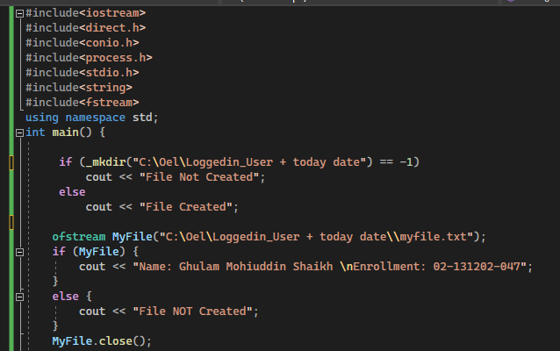

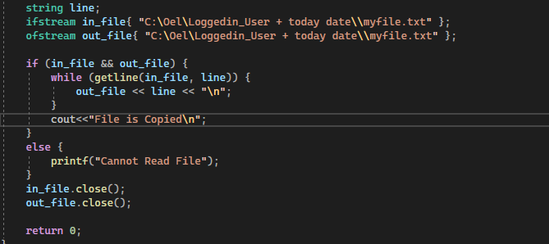

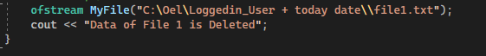

**OUTPUT:**

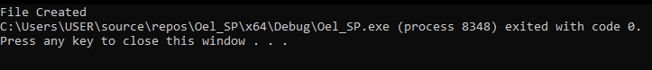

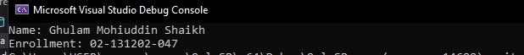





**TASK.2**

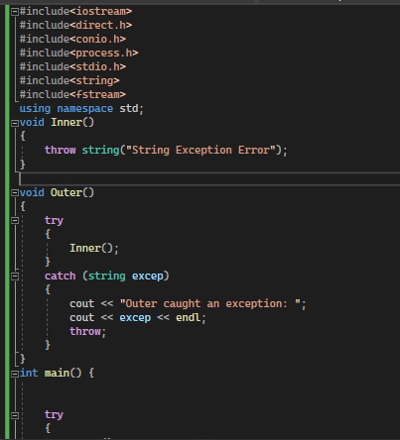

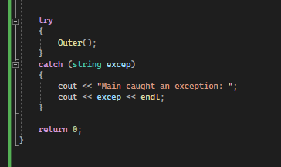

**OUTPUT:**



**TASK.3**

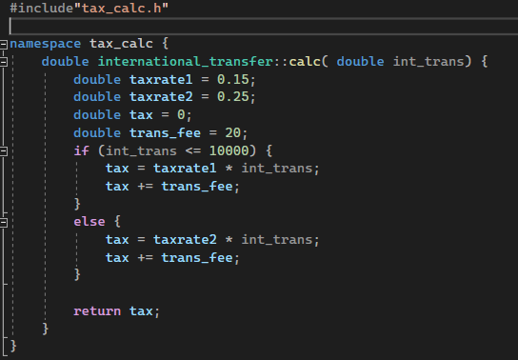

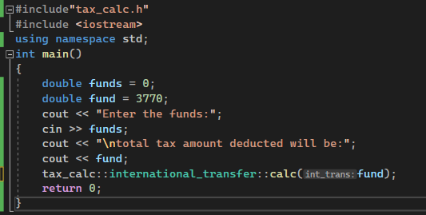

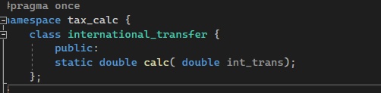

**OUTPUT:**



**TASK.4**

#include<stdio.h>

#include<sys/types.h>

#include<unistd.h>

int main()

{

pid_t pid;

pid = fork();

if (pid == 0)

{

printf("I am child and my parent is %d and my own PID is %d\n", getppid(), getpid());

}

else if (pid > 0)

{

printf("I am a Parent and my pid is %d\n", getpid());

}

return 0;

}

**OUTPUT:**

